

**01205241 Digital Circuit and Logic Design**

**Academic Year 2020, First Semester**

**Mini Project 2**

**Combinational Logic Circuit Design**

**Present to**

Asst.Prof. Dusit Thanapatay

**Presented to**

Miss Areeya Yiampanomkhun 6210554709 (sec 450)

Mr. Krit Jaithawin 6210554717 (sec 450)

Mr. Jakkaphob Kongthanarith 6210554725 (sec 450)

|  |  |  |  |  |  |  |  |  |  |  |  |  |  |  |
| --- | --- | --- | --- | --- | --- | --- | --- | --- | --- | --- | --- | --- | --- | --- |
| work  (50%) | Option | | | Neat& Safety  (10%) | Presentation  Q&A  (15%) | | Report (25%) | | | | | | | |
| Bonus  (20%) | Option Detail  (Add or reduce) | | Method  (15%) | | Item&prices  (3%) | | Prob&Soln  (5%) | | Neat  (2%) | |
|  |  |  |  | | |  | |  | |  | |  | |  |

**PREFACE**

This report are part of secound digital project in subject Digital Circuits and Logic Design semester 1/2020 sec 450 presented to Asst prof Dusit Thanapatay. We describe the project process and how can it work. We build 3 modes in this project which begins with ready mode , input mode and display mode.

Areeya Yiampanomkhun

Krit Jaithawin

Jakkaphob Kongthanarith

**Index**

-preface 2

-ready mode 3

-input mode 4

-display mode 5

**Ready Mode**

-When turn on the power , The circuit begins with  **ready mode**

-In this mode , all 4 digits of seven-segment display start blinking 1 Hz of “0000” three times

-After that show “0000” without blinking until there is some assert input.

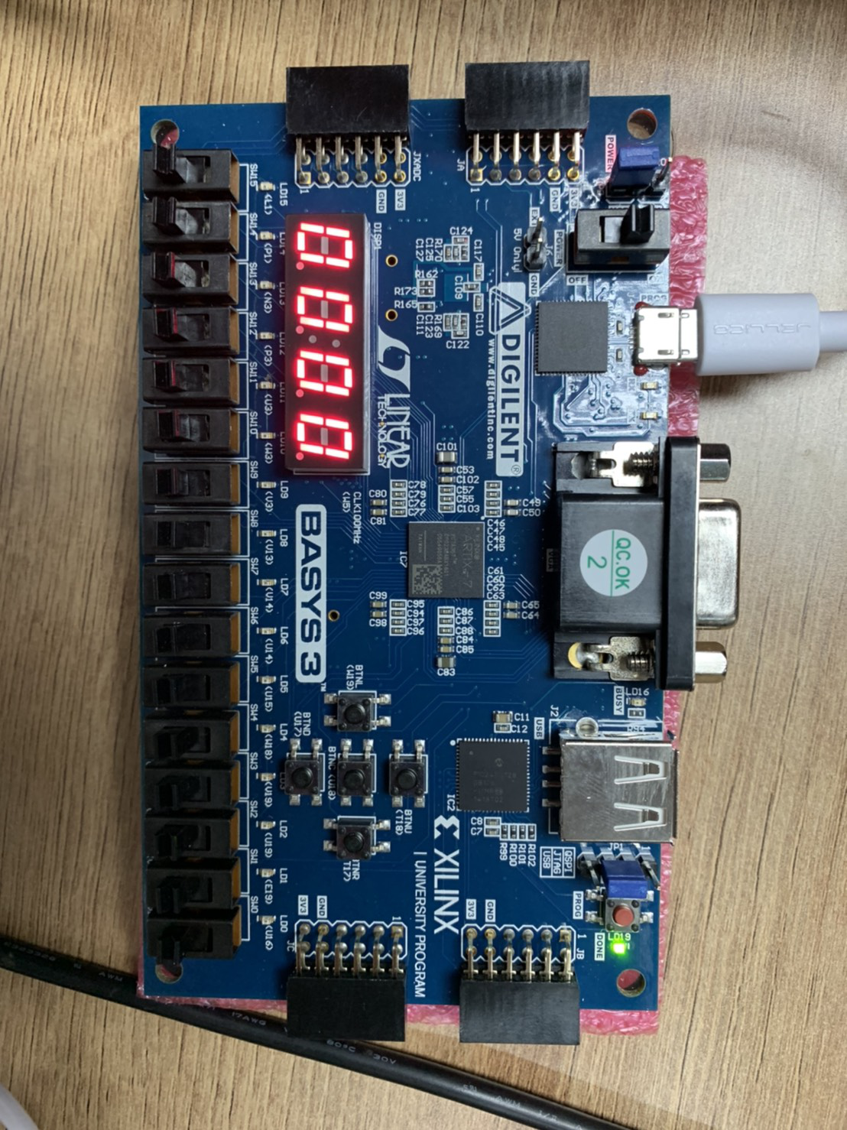

**Code working process :**

- Deferment clock form 10 Hz to 1 Hz (1 Hz = 1 sec )

- Count CLK until complete output blinking 3 times then CLK become 10 MHz

(Main Module)

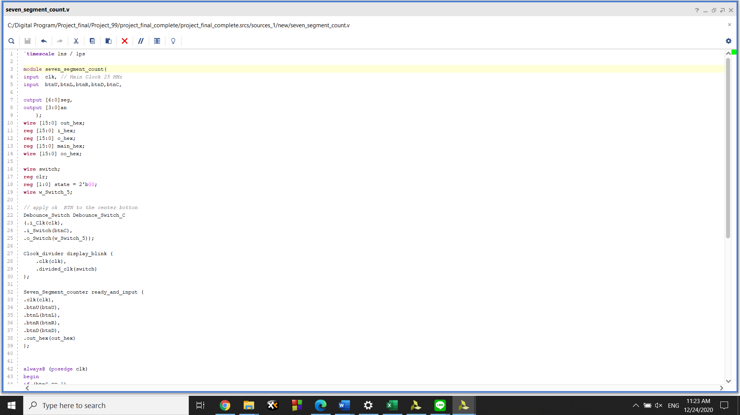

First we have to declare CLK, all of tool, input and output

**( Code : Blink)**

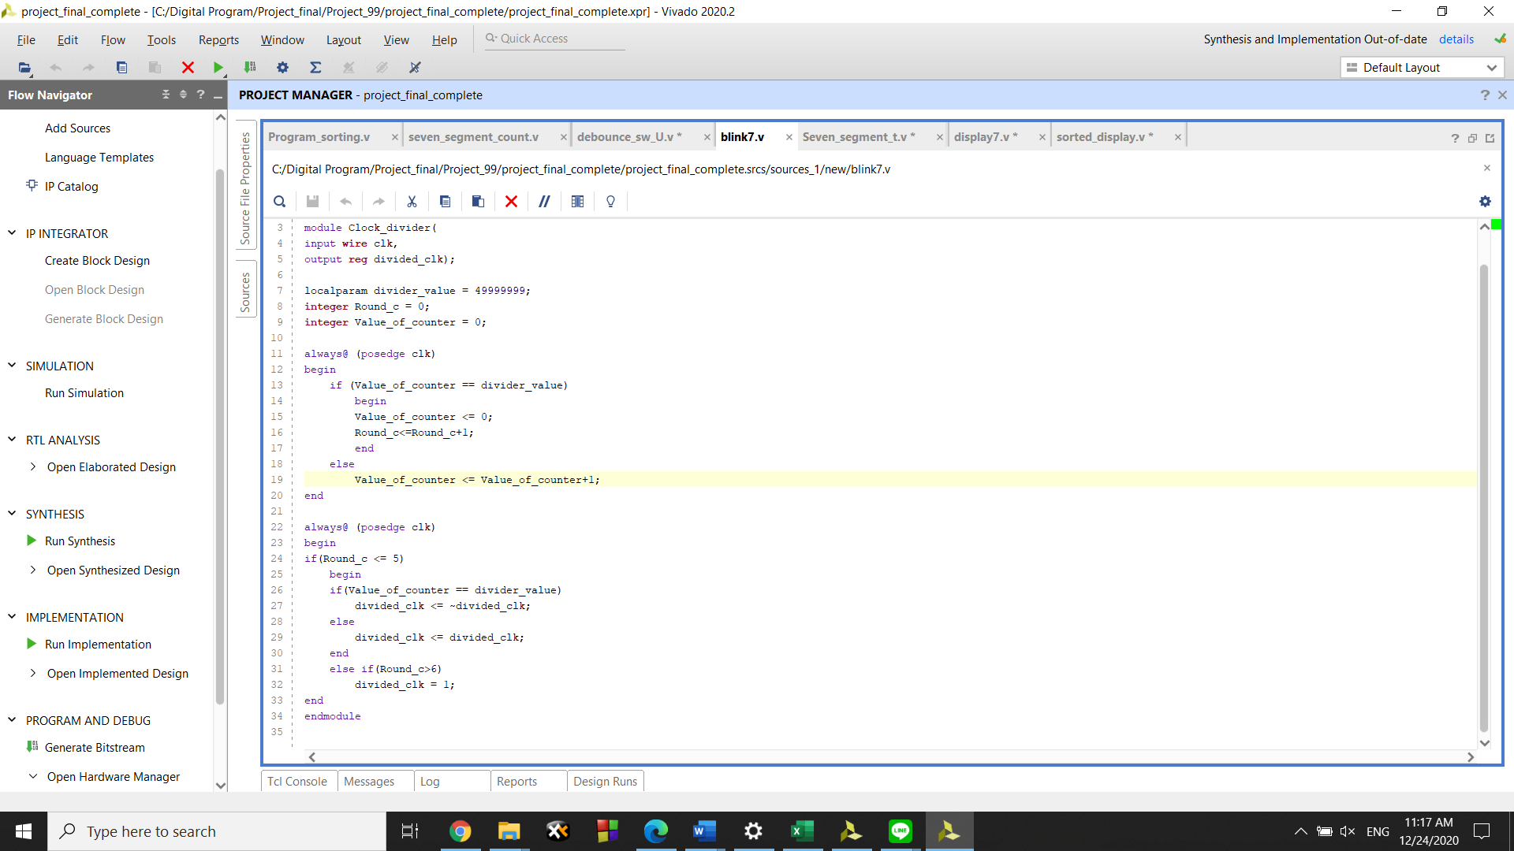

When we execute the program by clicking ‘Program Device’ the program will run while checking the ‘Value_of_Counter’ valuable, if it reached the value we set (aka ‘ Divider_value’ variable) it will opposite it current state (if the light is on, it will be turned off, on the other hand, if it off it will be turned on) and resetting itself back to 0 will increase value of ‘Round_c’ by 1., otherwise, it will increase value of ‘Value_of_counter’ by 1. This operation will continue until variable ‘Round_c’ value is higher than 6.

**(Code : Seven segment display)**

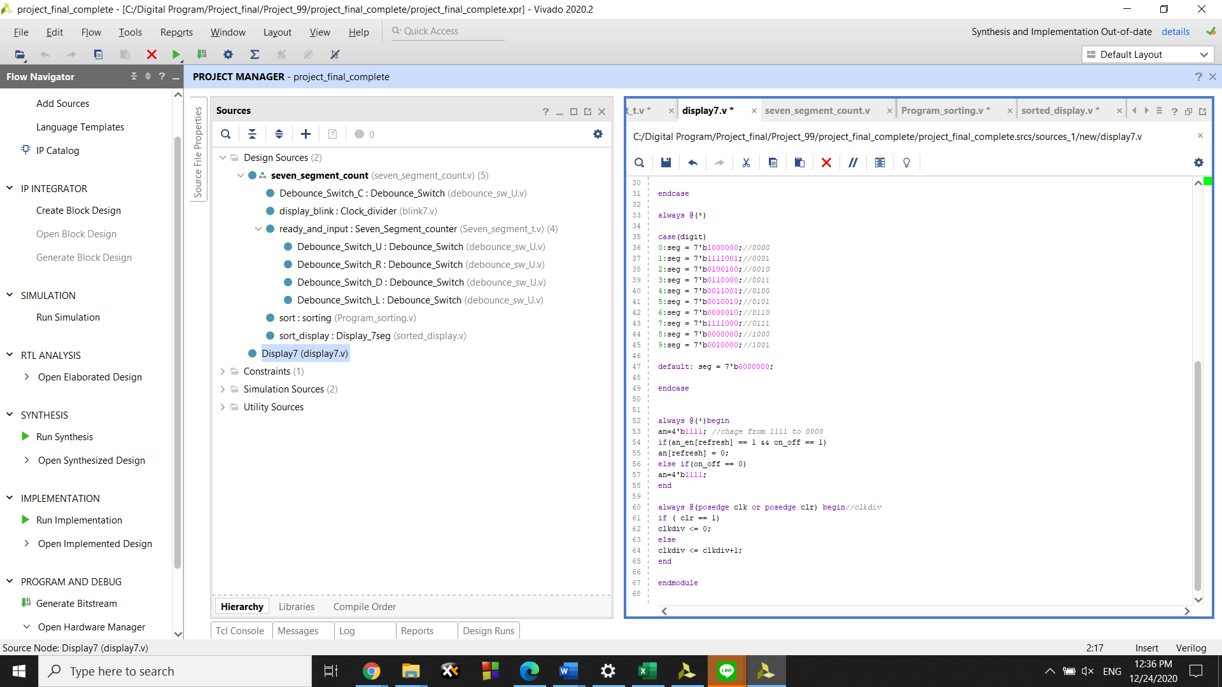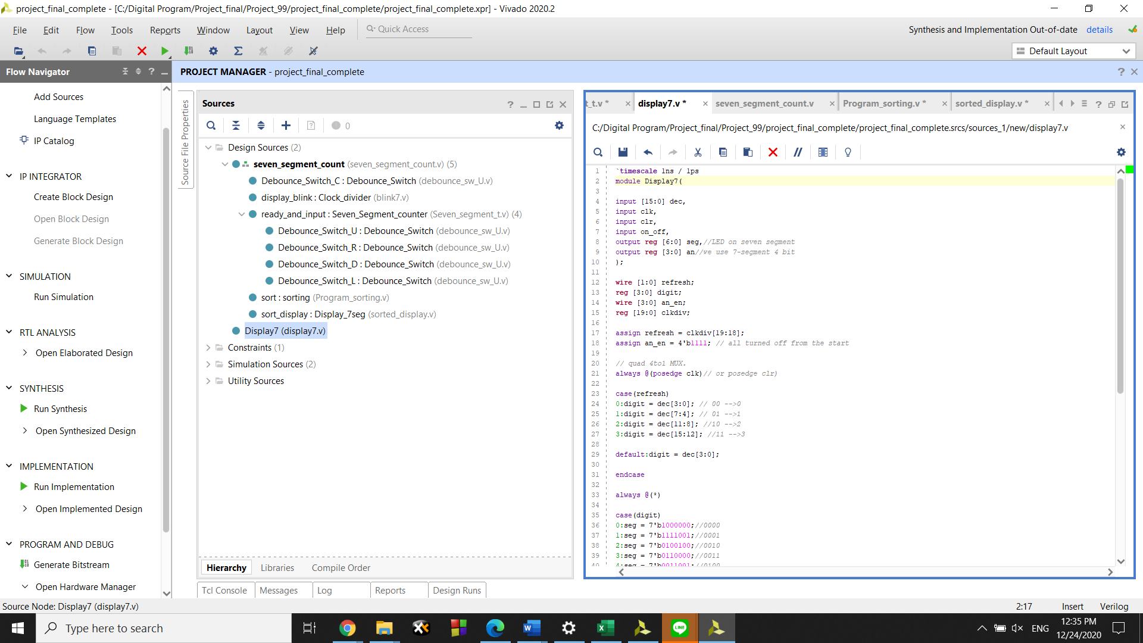

This code is use for display the seven segment.

**Input Mode**

When there is asserted input (S1,S2,S3,S4) the circuit changes into **input mode**  for each time when S1,S2,S3 or S4 is pressed, the 7-segment D1,D2,D3 and D4 shows 1 increment on its place in counting order 0-9 numbers

**Working process :**

- Build the debounce module for protectnoisebetween press switch no error

- Build the variable to keep the data.

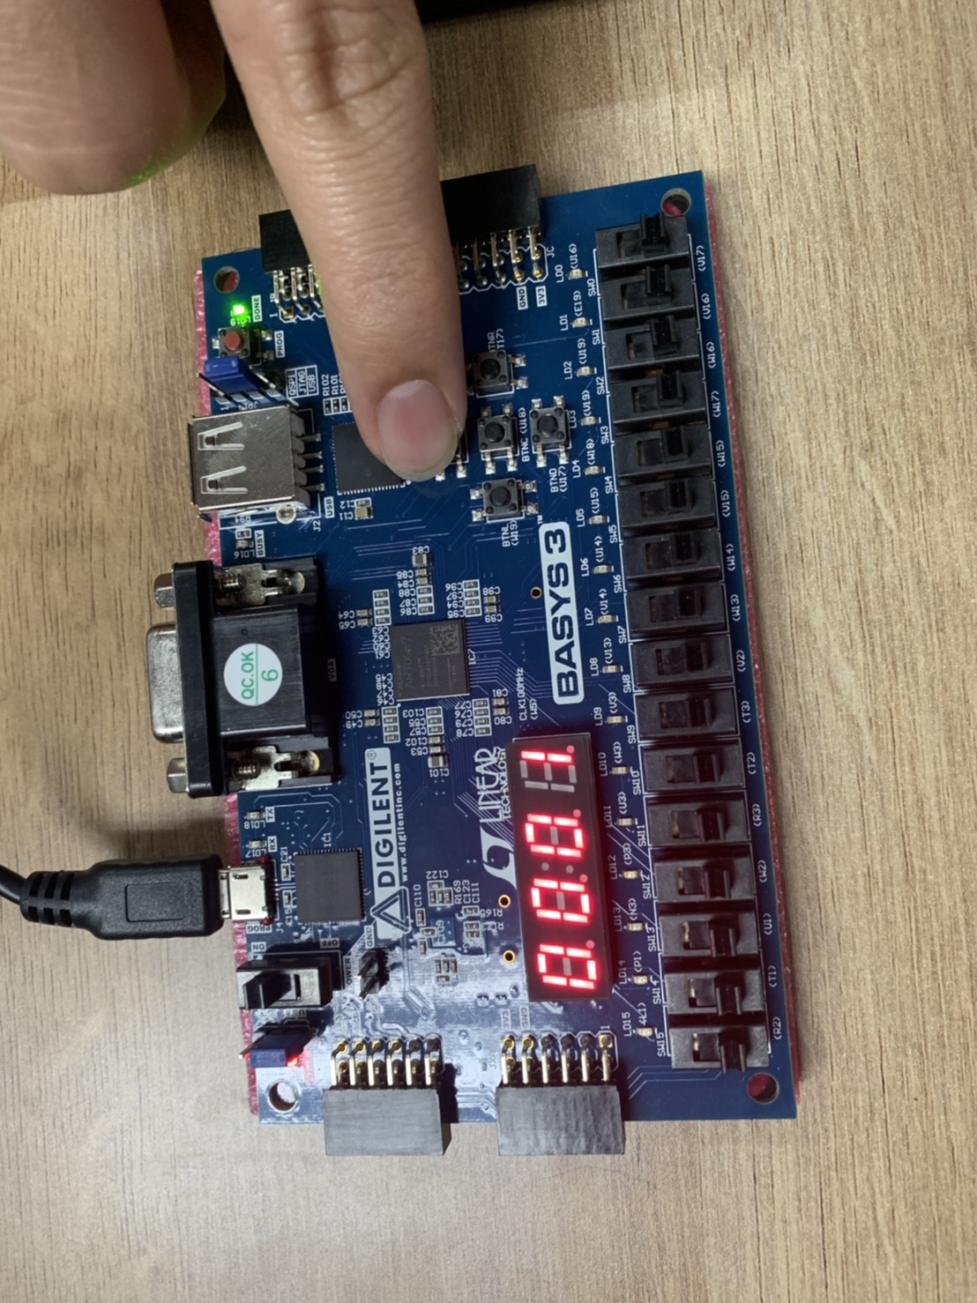

When we press the button, value of bit will be increased by 1, starting from 0.When the value increased to max(9). Pressing the button again will make it turn back to 1. This also applied to another button except the center button.

**(Code : Debounce)**

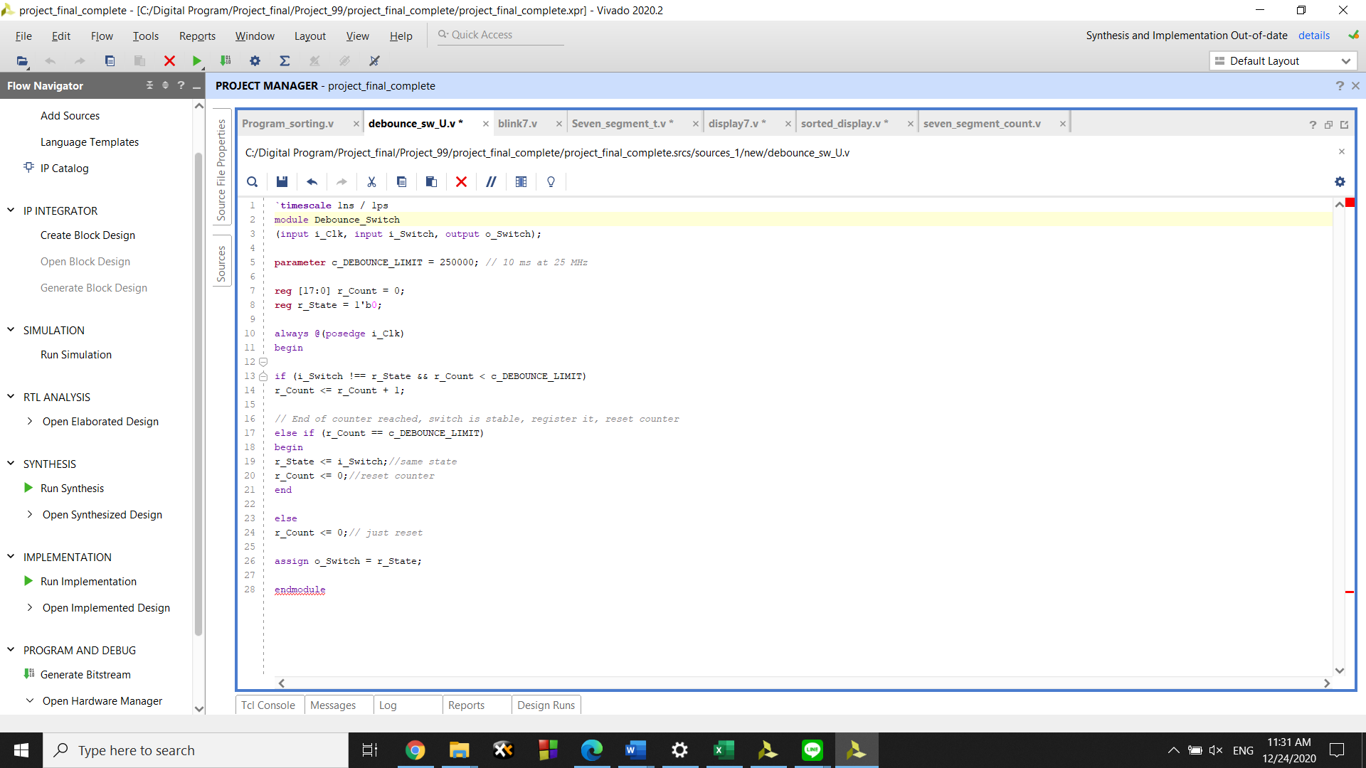

This program will erase all the noise that may cause an accident to programs, making it display the wrong input we expect.

**(Code : Seven segment counter)**

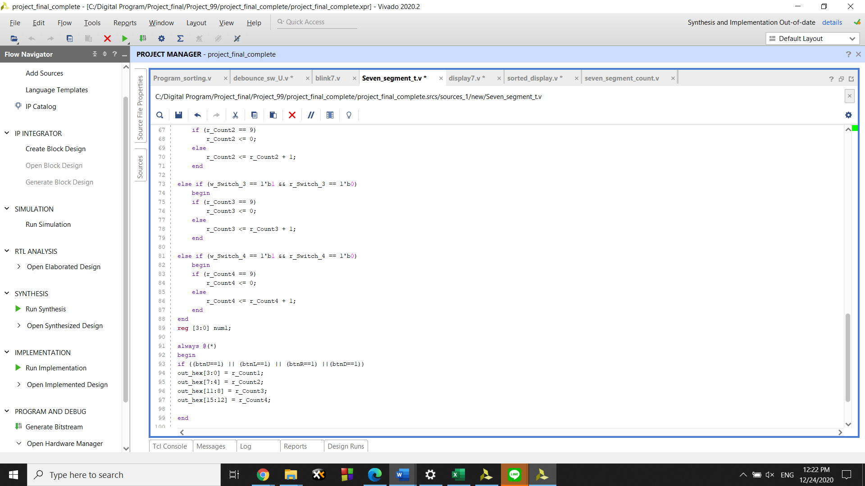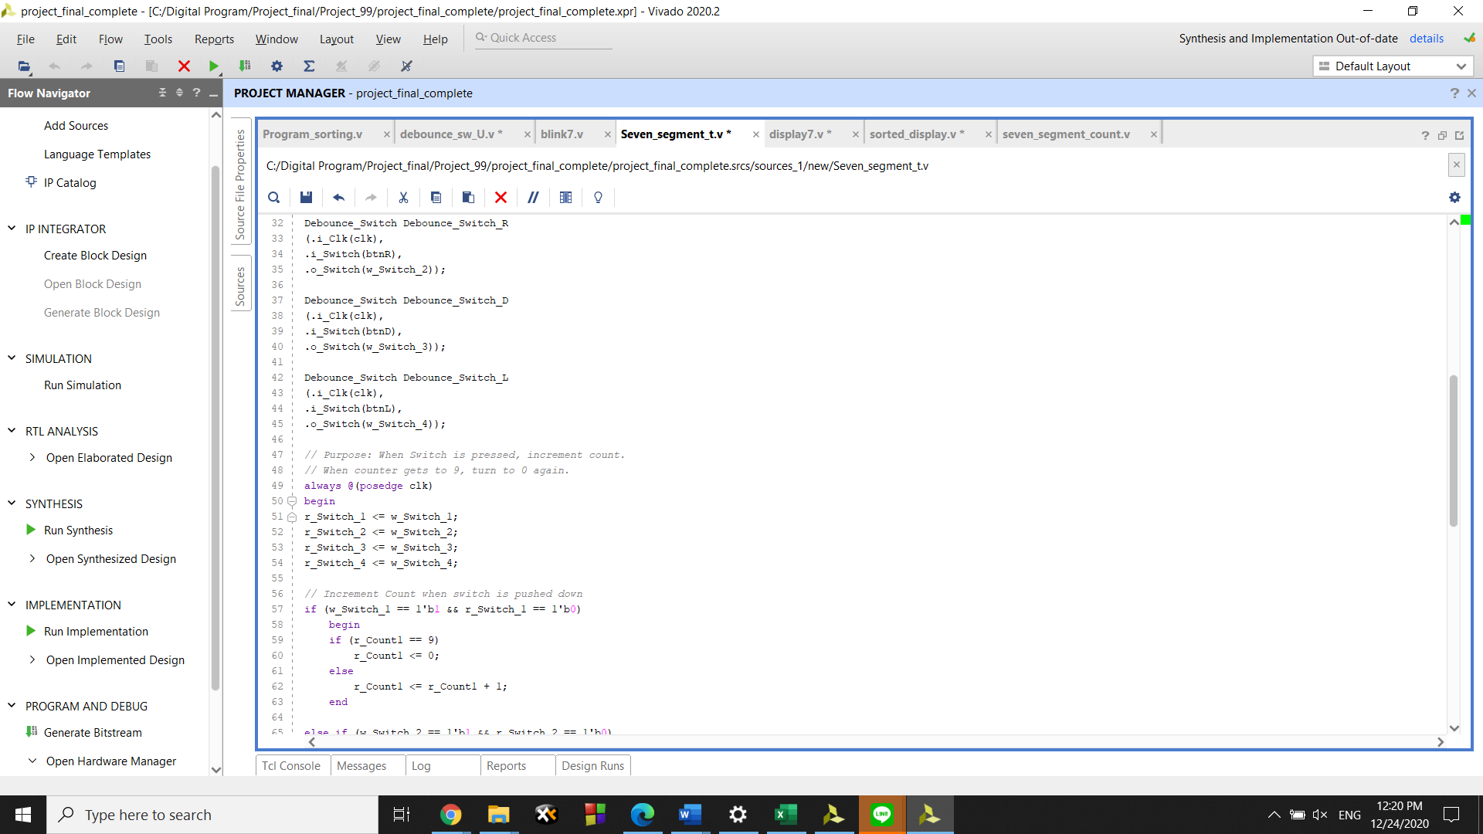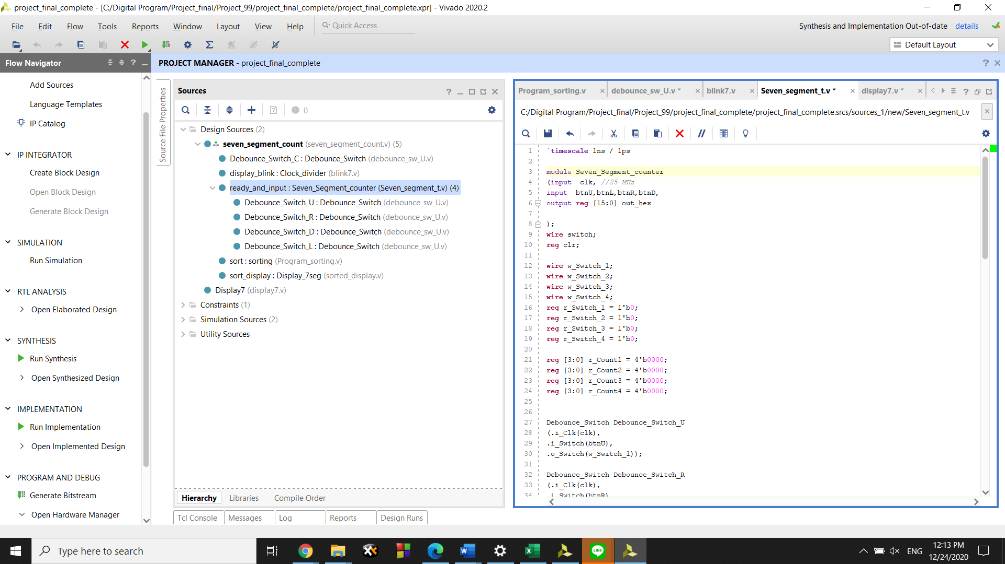

This part make program remember which button we want to inscribe our data at.

**(Code : Debounce switch)**

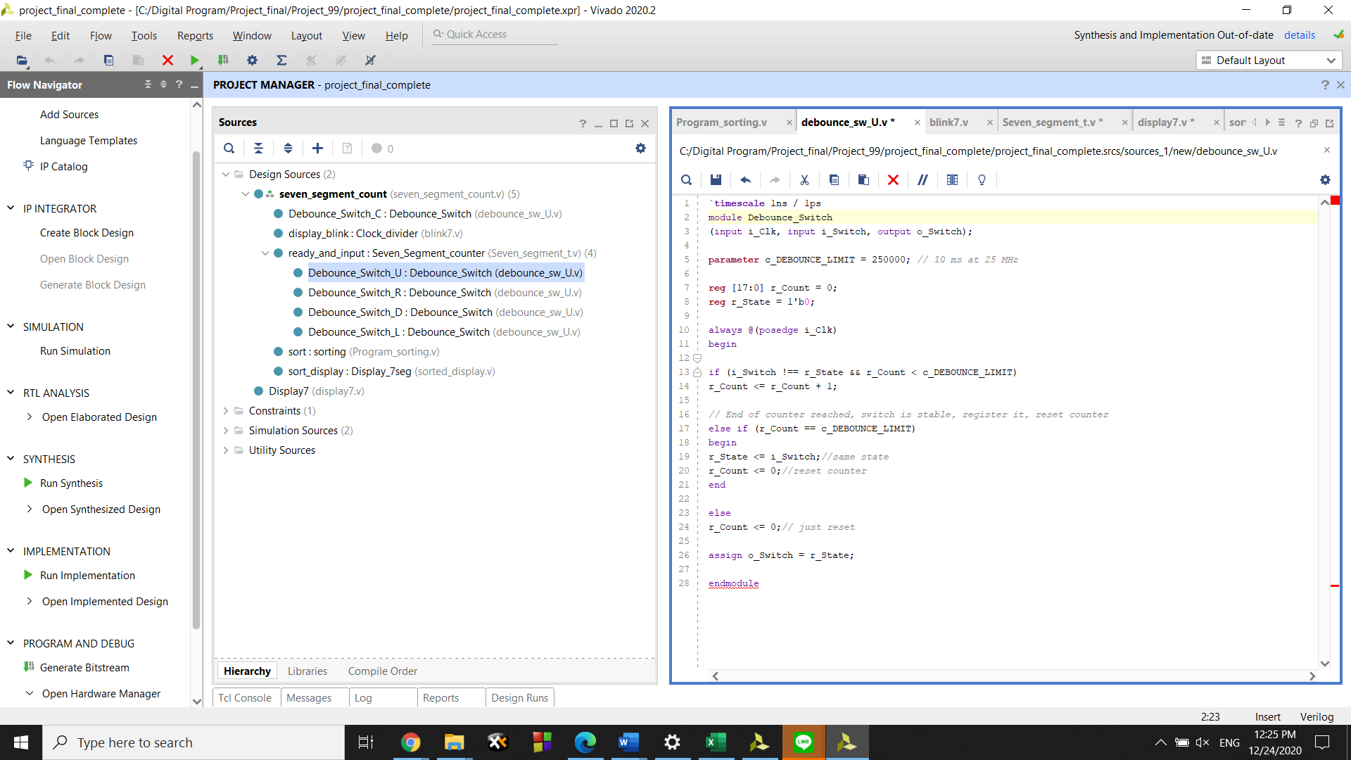

This is debounce of each switch. Making the program more accurately and reduce amount of mistake.

**(Code : Sorting)**

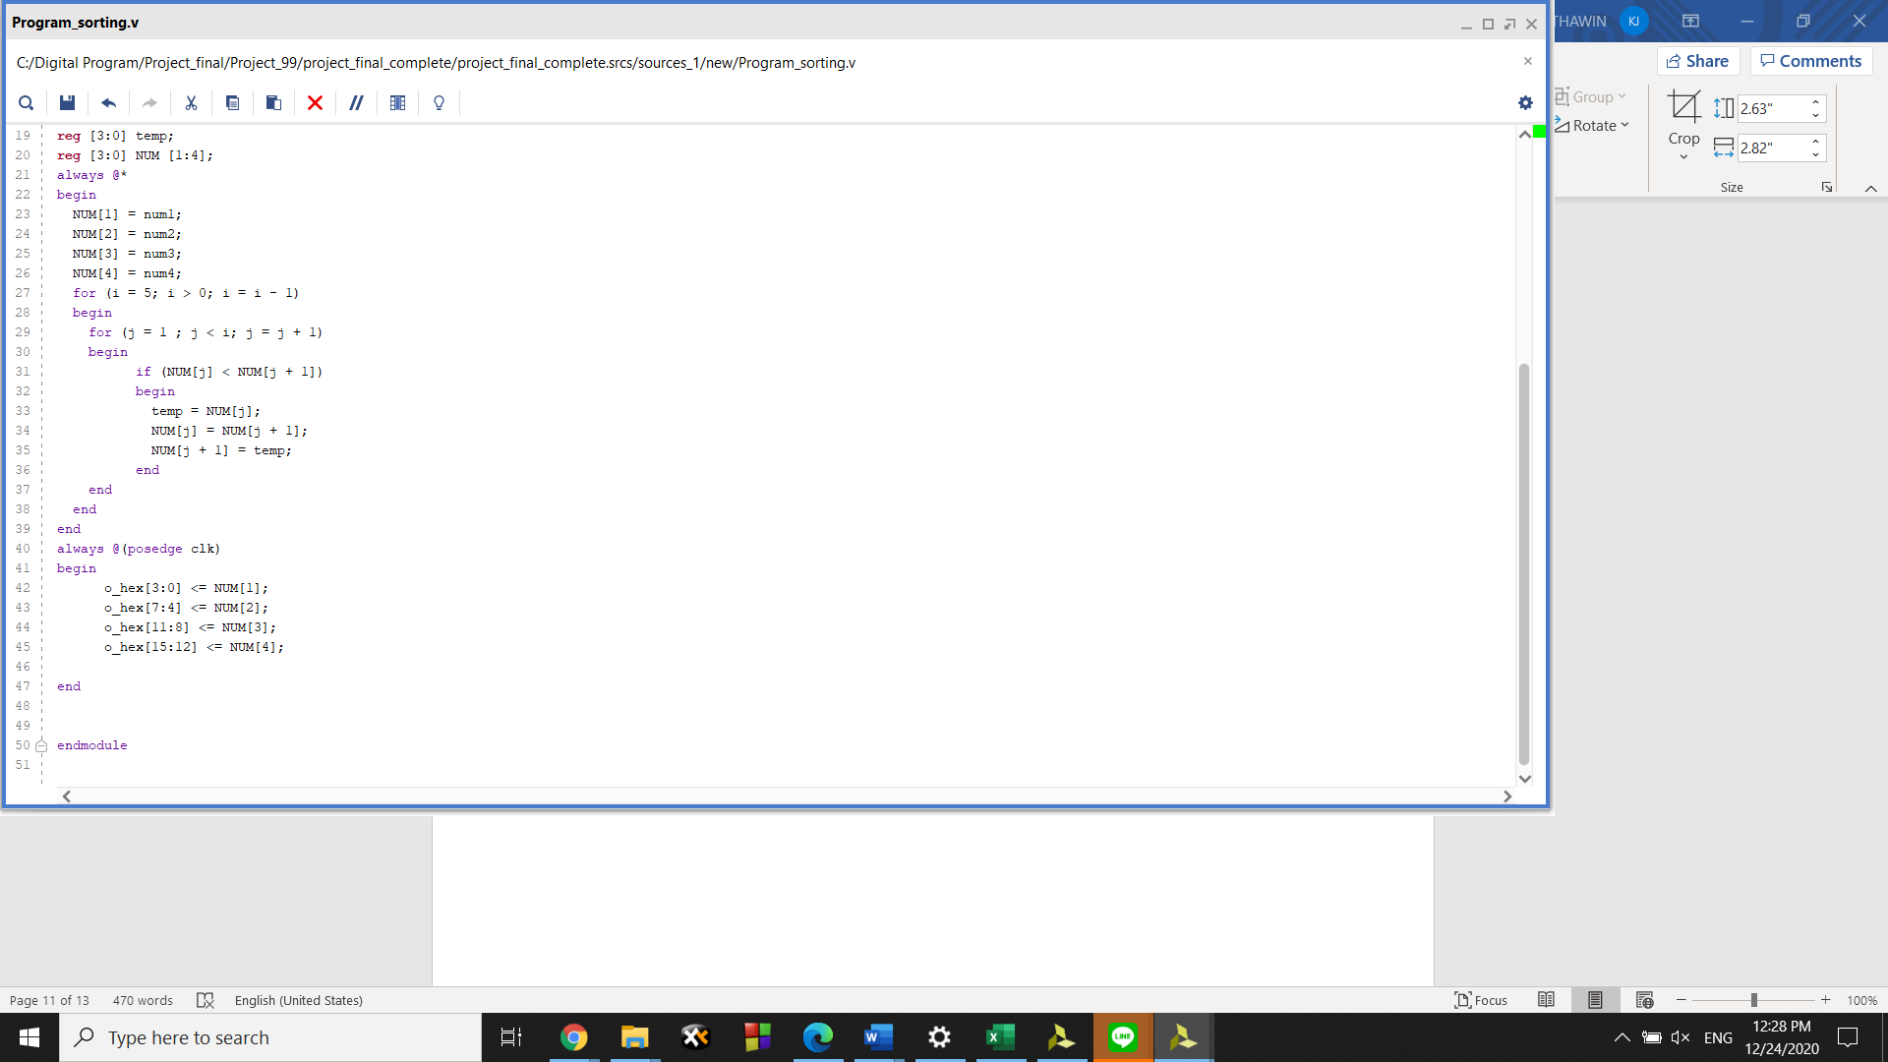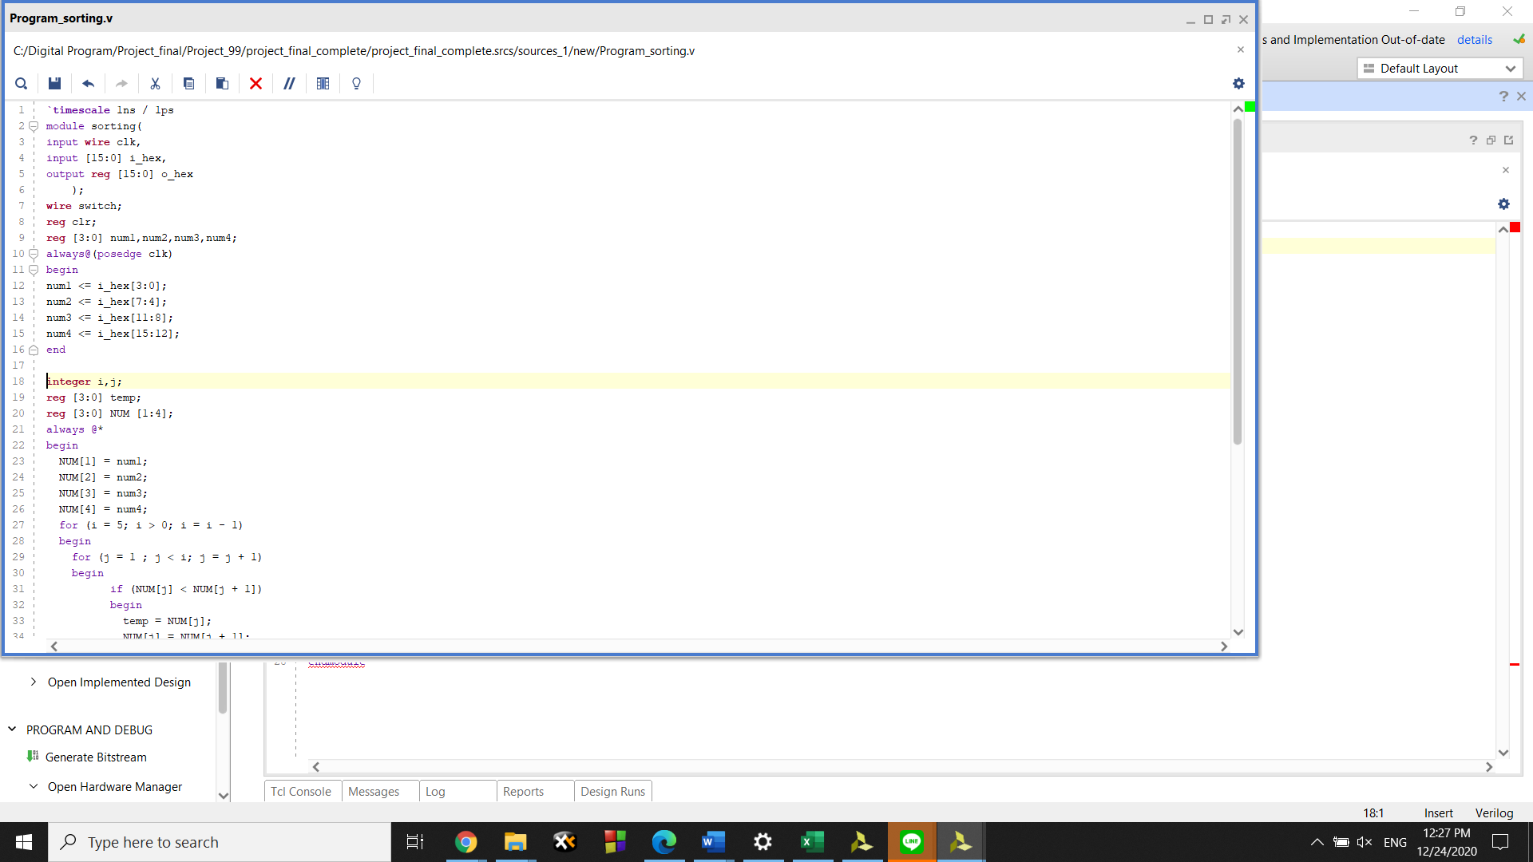

This process will compare number stored in each digit. Program will choose the most far-right number and then compare to the number next to the left, put the number that have least value on the left side and continue comparing. When the number of the most far-left side is surely a least value of number, the program will started again until the logic that we have written is all right and rearrange it .

**Display Mode**

When OK is pressed switch the program will go to this **display mode**

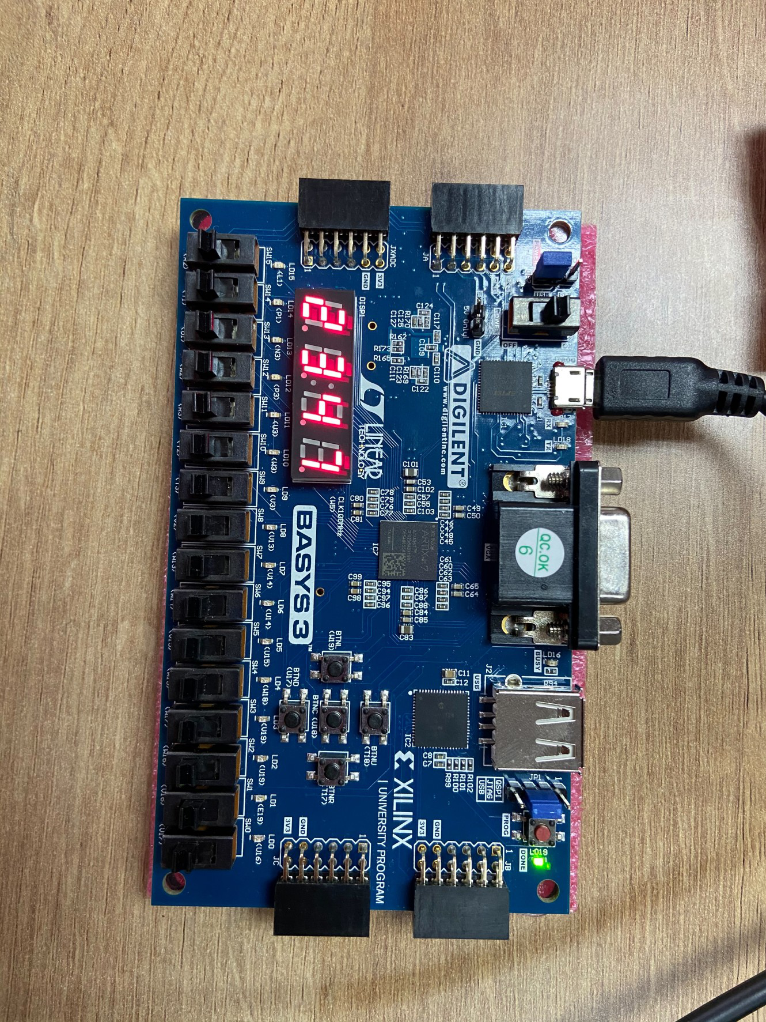

**(Code : Display sorting)**

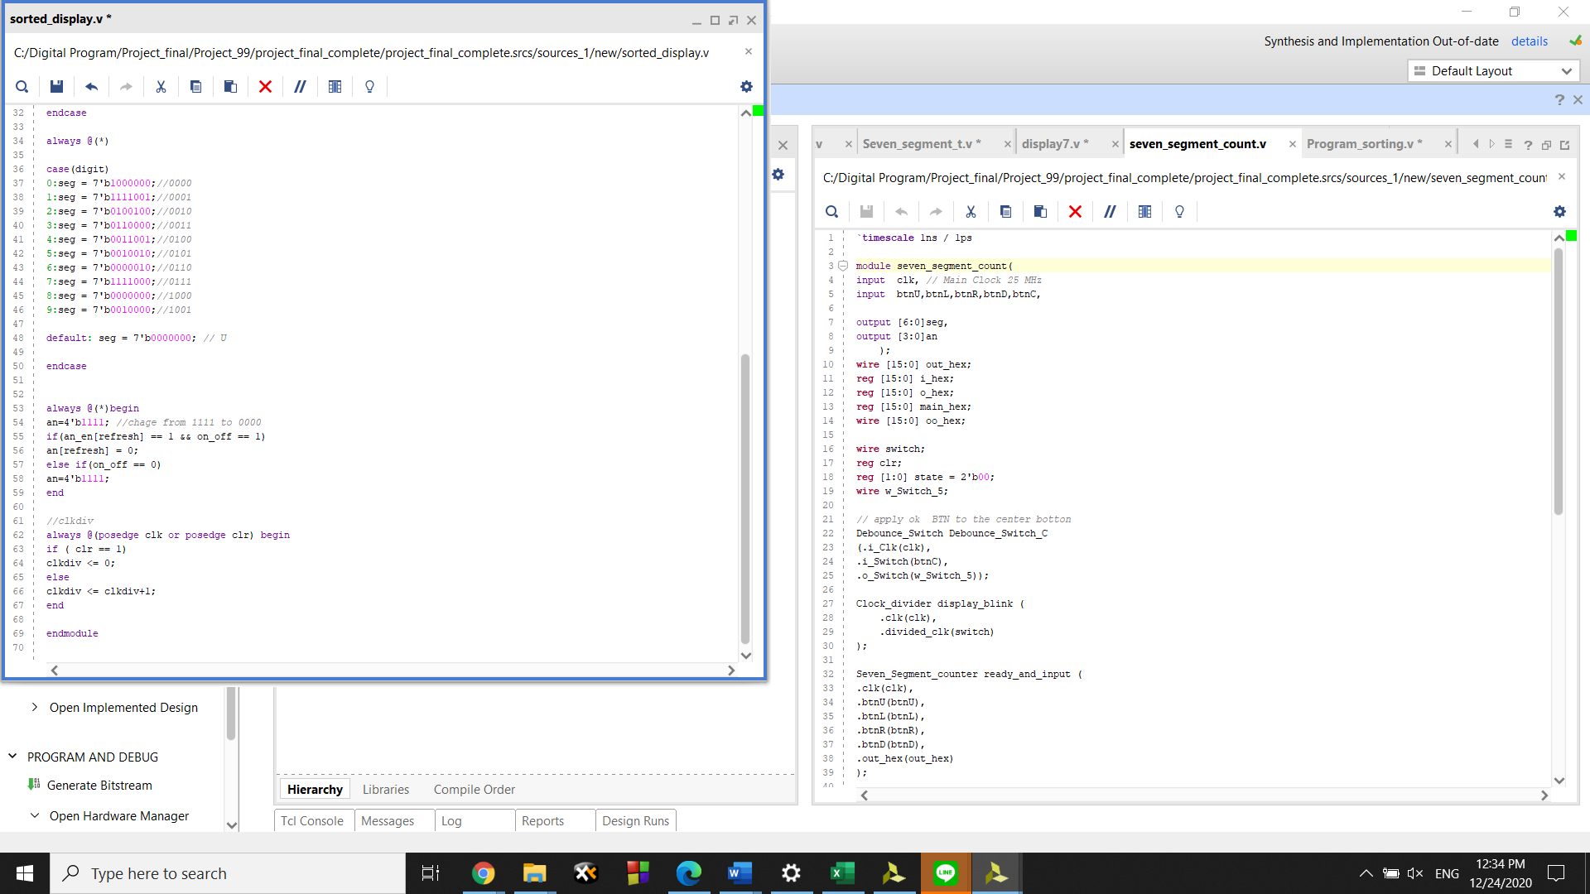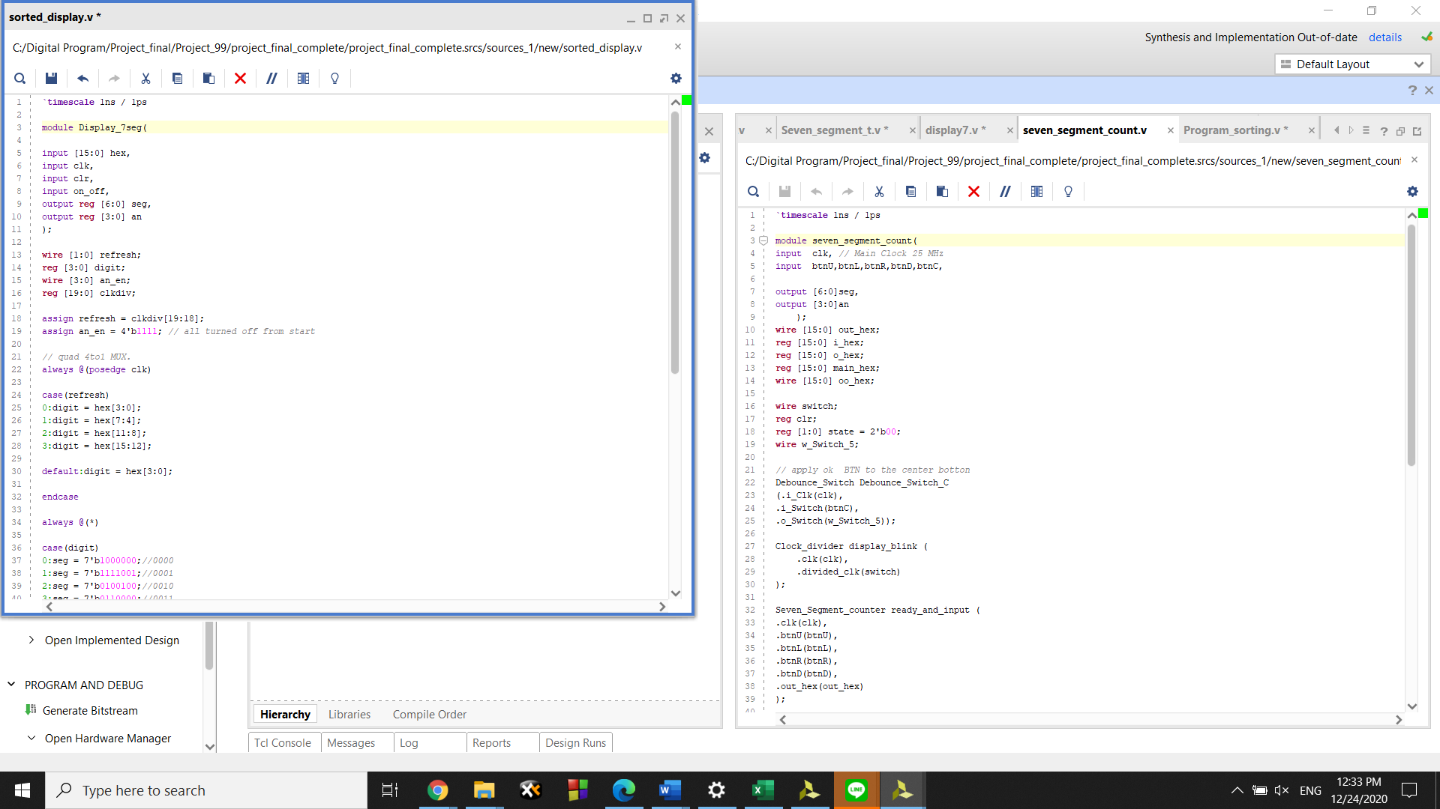

The code is used for making bord display value that have been stored in the current variable that we select.

**Reference:**

https://www.nandland.com/vhdl/modules/binary-to-7-segment.html

https://youtu.be/iei1EugtQvQ

[How to Debounce a Switch in an FPGA (nandland.com)](https://www.nandland.com/articles/debounce-switch-in-fpga.html)

DIGITAL SYSTEM DESIGN WITH FPGA book from Mc graw hill Edutcation